DBMS – Assignment 1

Name: Parimal Kulkarni

Prn: 22070122138

Div: CSE B2

Batch: 22-26

1. What are ER Diagrams? What is their significance in DBMS?

An Entity Relationship Diagram (ER Diagram) visually illustrates the relationships between entities in a database. It is a fundamental tool in Database Management Systems (DBMS) for designing and modeling databases efficiently. The diagram highlights connections between various entities, aiding in the conceptualization and organization of database structures. ER Diagrams help define entity attributes and their associations, providing a clear blueprint for database developers.

1. Explain the conversion process from ER to Relational.

Identify entities and attributes in the ER model.

Create tables for each entity with attributes as columns.

Designate the primary key as the attribute(s) ensuring uniqueness.

Establish relationships between tables using foreign keys if needed.

**Implementation Question**:- Draw an ER diagram for the following problem statements and then convert them into database relational schema.

1. CAR Rental Management
   * One customer can rent one car.
   * Each car has one manufacturer.
   * Each manufacturer can manufacture many types of cars.
   * Each car has its own maintenance schedule.
   * The revenue is generated based on number of days the car was rented.
   * The company has branches in 5 major cities.
   * The companies also have 5 employees per branch.
   * Initial rental requests are handled by employees.
2. **ER Diagram**

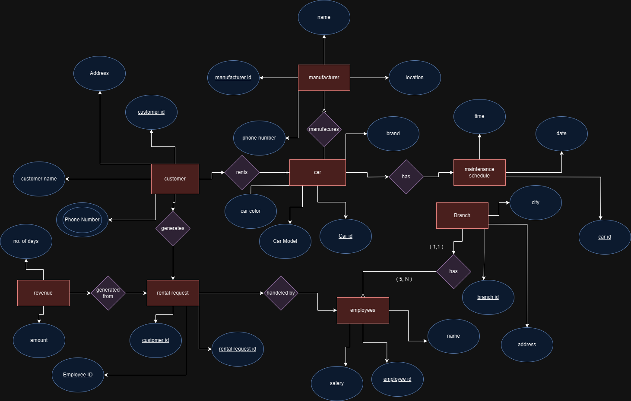

1. **Customer Table:**
   * Tuple Customer : (Customer Id, Address, Customer Name, Phone Number)
   * Table:

| **Customer Id** | **Address** | **Customer Name** | **Phone Number** |
| --- | --- | --- | --- |
| 101 | 123 Main St | John Doe | 555-1234, 555-5678 |
| 102 | 456 Oak Ave | Jane Smith | 555-9876 |
| 103 | 789 Elm St | Bob Johnson | 555-5432, 555-8765 |
| 104 | 101 Pine Rd | Mary White | 555-2345 |

1. **Car Table:**
   * Tuple Car : (Car Id, Car Color, Car Model, Brand)
   * Table:

| **Car Id** | **Car Color** | **Car Model** | **Brand** |
| --- | --- | --- | --- |
| 201 | Blue | Sedan | Toyota |
| 202 | Red | SUV | Honda |
| 203 | Silver | Coupe | Ford |
| 204 | Black | Hatchback | Chevrolet |

1. **Manufacturer Table:**
   * Tuple Manufacturer: (Manufacture Id, Location, Phone Number, Name)
   * Table:

| **Manufacture Id** | **Location** | **Phone Number** | **Name** |
| --- | --- | --- | --- |
| 301 | Detroit | 555-1111 | Ford |
| 302 | Tokyo | 555-2222 | Toyota |
| 303 | Seoul | 555-3333 | Hyundai |
| 304 | Stuttgart | 555-4444 | Mercedes-Benz |

1. **Maintenance Schedule Table:**
   * Tuple maintenance schedule: (Time, Date, Car Id)
   * Table:

| **Time** | **Date** | **Car Id** |
| --- | --- | --- |
| 10AM | 2024-02-01 | 201 |
| 2PM | 2024-02-03 | 203 |
| 1PM | 2024-02-05 | 202 |
| 3PM | 2024-02-07 | 204 |

1. **Branch Table:**
   * Tuple Branch: (Branch Id, City, Address)
   * Table:

| **Branch Id** | **City** | **Address** |
| --- | --- | --- |
| 401 | New York | 789 Broadway St |
| 402 | Los Angeles | 456 Hollywood Blvd |
| 403 | Chicago | 321 State St |
| 404 | Miami | 555 Ocean Dr |

1. **Employees Table:**
   * Tuple Employees: (Employee Id, Name, Salary)
   * Table:

| **Employee Id** | **Name** | **Salary** |
| --- | --- | --- |
| 501 | Alex Turner | 60000 |
| 502 | Emily White | 75000 |
| 503 | Michael Brown | 55000 |
| 504 | Sarah Miller | 70000 |

1. **Rental Request Table:**
   * Tuple Rental Request: (Rental Request Id, Customer Id)
   * Table:

| **Rental Request Id** | **Customer Id** |
| --- | --- |
| 601 | 101 |
| 602 | 103 |
| 603 | 104 |
| 604 | 102 |

1. **Revenue Table:**
   * Tuple Revenue: (No. of Days, Amount)
   * Table:

| **No. of Days** | **Amount** |
| --- | --- |
| 3 | 300 |
| 5 | 500 |
| 4 | 400 |
| 7 | 700 |

1. SIU Library Management System.
   * SIU library there can be individual institute libraries.
   * Library has members.
   * Library buys books of many publishers.
   * Sellers sell books of many publishers.
   * Library contains books
   * Books are written by one/many authors.
   * Authors’ books are published by publishers.

ER diagram:

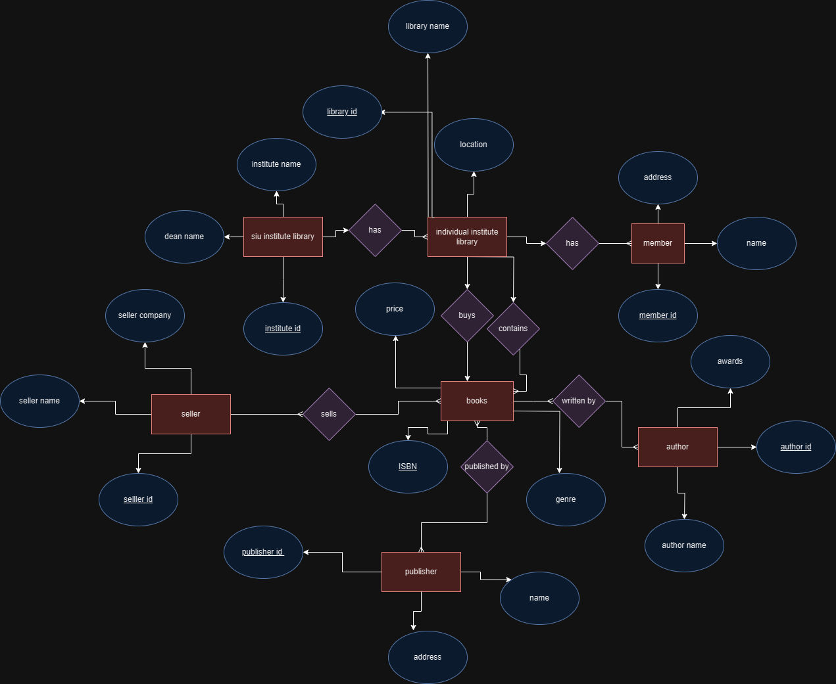

**SIU Institute Library:**

| **Institute_ID** | **Dean_Name** | **Institute_Name** |
| --- | --- | --- |
| 1 | John Smith | SIU College |
| 2 | Jane Doe | SIU School |
| 3 | Bob Johnson | SIU Academy |
| 4 | Mary White | SIU Institute |

**Tuple Format:**

* Siu institute Library: (Institute_ID, Dean_Name, Institute_Name)

**Individual Institute Library:**

| **Library_ID** | **Library_Name** | **Location** |
| --- | --- | --- |
| 101 | Main Library | Building A |
| 102 | Science Library | Building B |
| 103 | Arts Library | Building C |
| 104 | Tech Library | Building D |

**Tuple Format:**

* Individual institute Library: (Library_ID, Library_Name, Location)

**Member:**

| **Member_ID** | **Name** | **Address** |
| --- | --- | --- |
| 201 | Alice Jones | 123 Main St, City |
| 202 | Bob Miller | 456 Oak St, Town |
| 203 | Cindy Lee | 789 Pine St, Village |
| 204 | David Chen | 321 Elm St, Hamlet |

**Tuple Format:**

* Member: (Member_ID, Name, Address)

**Seller:**

| **Seller_ID** | **Seller_Name** | **Seller_Company** |
| --- | --- | --- |
| 301 | XYZ Books | ABC Publishing |
| 302 | QuickBooks | DEF Publishers |
| 303 | BestDeals | GHI Publications |
| 304 | MegaBooks | JKL Printing |

**Tuple Format:**

* Seller: (Seller_ID, Seller_Name, Seller_Company)

**Books:**

| **ISBN** | **Price** | **Genre** |
| --- | --- | --- |
| 978-1234567 | 25.99 | Fiction |
| 978-2345678 | 19.99 | Mystery |
| 978-3456789 | 32.50 | Science |
| 978-4567890 | 15.75 | History |

**Tuple Format:**

* Books: (ISBN, Price, Genre)

**Author:**

| **Author_ID** | **Awards** | **Author_Name** |
| --- | --- | --- |
| 401 | Nobel Prize | John Writer |
| 402 | Pulitzer | Jane Novelist |
| 403 | Booker | Bob Scribe |
| 404 | Hugo | Mary Wordsmith |

**Tuple Format:**

* Author: (Author_ID, Awards, Author_Name)

**Publisher:**

| **Publisher_ID** | **Name** | **Address** |
| --- | --- | --- |
| 501 | ABC Press | 111 Publishing St |
| 502 | DEF Books | 222 Book Street |
| 503 | GHI Prints | 333 Printing Avenue |
| 504 | JKL Publishers | 444 Press Lane |

**Tuple Format:**

* Publisher: (Publisher_ID, Name, Address)

3) Online Grocery Ordering System

▪ Customer must orders one or more items. Each customer is identified by

his/her name. The postal address and email address of the customer are also

required for the correct placement of order.

▪ Items have their name and price to be shown to the customers.

▪ Shopping carts are created by the orders of the customers.

▪ Shopping carts contain at least one item.

▪ An order must have at least one requested item.

▪ Not all items have customers.

▪ Distinct companies produce distinct items which are differentiated by the

company’s name.

▪ Payment must be made via credit cards. The payment process has to be done

after the credit card’s verification.

Er diagram:

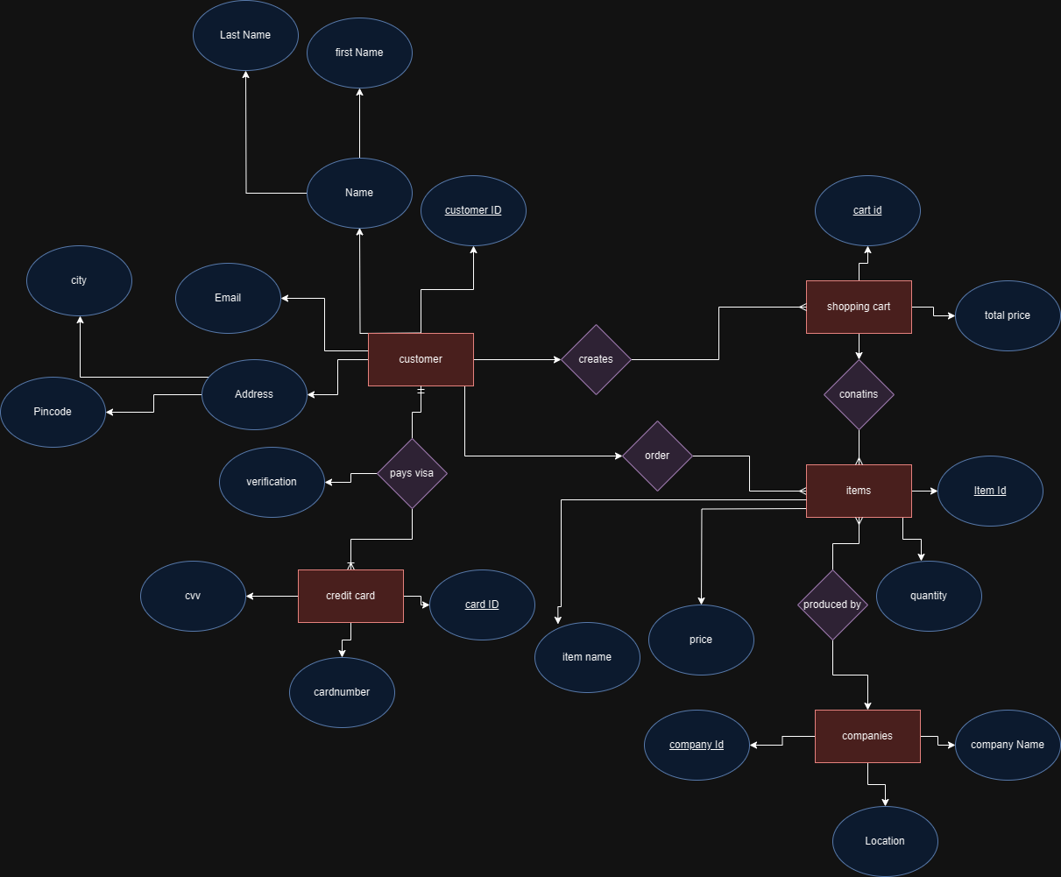

1. Customer Table:
   * Tuple Format Customer: (customer_id, first_name, last_name, email, pincode, city)
   * Table Format:

| **customer_id** | **first_name** | **last_name** | **email** | **pincode** | **city** |
| --- | --- | --- | --- | --- | --- |
| 1 | John | Doe | john@email.com | 12345 | City1 |
| 2 | Jane | Smith | jane@email.com | 67890 | City2 |
| 3 | Bob | Johnson | bob@email.com | 45678 | City3 |
| 4 | Alice | Brown | alice@email.com | 98765 | City4 |

1. Shopping Cart Table:
   * Tuple Format Cart: (cart_id, total_price)
   * Table Format:

| **cart_id** | **total_price** |
| --- | --- |
| 101 | 50.00 |
| 102 | 75.50 |
| 103 | 30.25 |
| 104 | 100.00 |

1. Items Table:
   * Tuple Format Item: (item_id, quantity)
   * Table Format:

| **item_id** | **quantity** |
| --- | --- |
| 201 | 3 |
| 202 | 1 |
| 203 | 5 |
| 204 | 2 |

1. Companies Table:
   * Tuple Format Companies: (company_id, company_name, location)
   * Table Format:

| **company_id** | **company_name** | **location** |
| --- | --- | --- |
| 301 | ABC Inc. | Location1 |
| 302 | XYZ Corp. | Location2 |
| 303 | LMN Co. | Location3 |
| 304 | PQR Ltd. | Location4 |

1. Credit Card Table:
   * Tuple Format Credit Card: (card_id, card_number, cvv)
   * Table Format:

| **card_id** | **card_number** | **cvv** |
| --- | --- | --- |
| 401 | 1234-5678-9101 | 456 |
| 402 | 9876-5432-1098 | 789 |
| 403 | 5678-1234-9012 | 123 |
| 404 | 3456-7890-2109 | 567 |